Stud Center Quality Check Setup / Documentation
Sam Morstein
11/29/22

Introduction
The Stud Center Quality Check script is a Python GUI that allows for the visualization of an arbitrary number of studs placed by a robot. This will go through each aspect including set up and troubleshooting/maintenance.

Python

Software Installation
The script was developed with Anaconda running Python 3.8.5. This was originally on WUSS, but it has been removed. There still might be a way to request the software through BMW. If not, the version that I built the script with is version 2020.11, which can be found at https://repo.anaconda.com/archive/ . “Anaconda3-2020.11-Windows-x86.exe” and “Anaconda3-2020.11-Windows-x86_64.exe” I think would both work. I’m not sure if there is a license required and if you could get one.
In case Anaconda cannot be obtained, Python can be downloaded from WUSS or from the internet with no IDE. On WUSS, only older versions of Python are available:
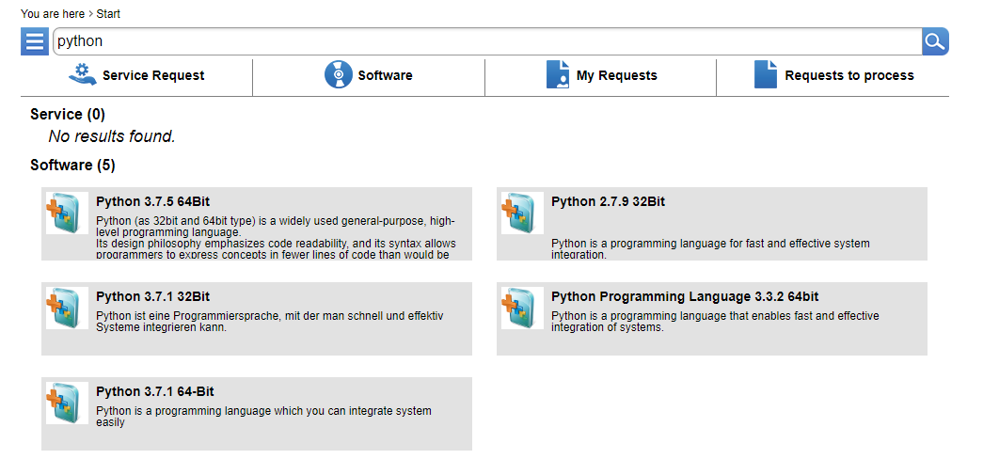
Python 3.7.5 might work but I am not 100% sure of that. Certain libraries that are required may not work properly with the code. Python 3.8.5 can be downloaded from the internet at https://www.python.org/downloads/release/python-385/ . An IDE of your choice can be downloaded which should work to allow you to easily run the script.

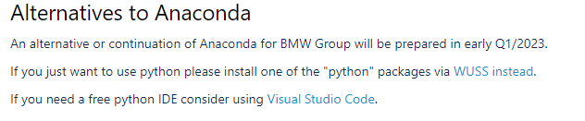

Script Setup
The script uses an accompanying file “Folder List.xlsx” which has the PC names that contain stud guns and the robot numbers of the PC. This allows for the list of PCs to be changed without changing the code itself. Unfortunately, some PCs are configured abnormally and will need to be hard coded as well as being added to the spreadsheet.
With a version of Python installed, the script should be able to be opened and viewed. You should see something like this. 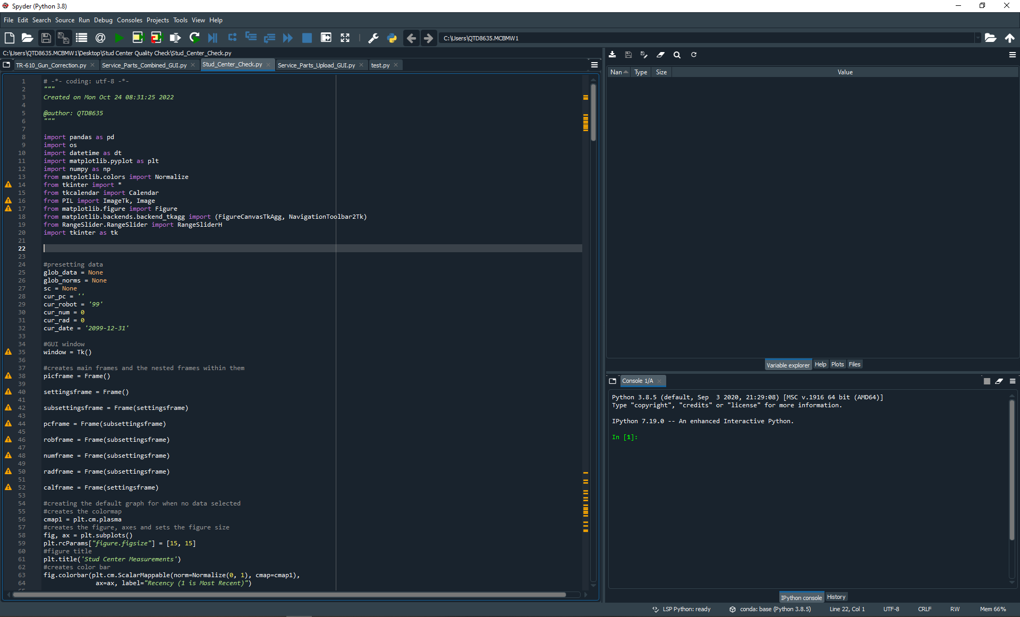
The script will not be able to run without erroring for 2 reasons: it requires additional libraries that are not installed and file paths are not properly configured. First, we will fix the all of the file paths in the script, which will help with the library installation.
File paths on lines 108,126, and 171 will potentially need to be changed.
Line:
108. This line reads in “Folder List.xlsx”. This will need to be changed to the file path where the spreadsheet is stored on your computer.
126. This line creates the file path into the INOS folder for whatever PC is selected. I used the drive letter “Z”. If the drive is mapped to a different letter on your machine, then this line will need to be changed.
171. This line creates the file path to the .txt being read into the script. I used the drive letter “Z”. If the drive is mapped to a different letter on your machine, then this line will need to be changed.

Once all the file paths are updated, the additional libraries can be installed. The libraries that will be needed can be seen at the top of the script:
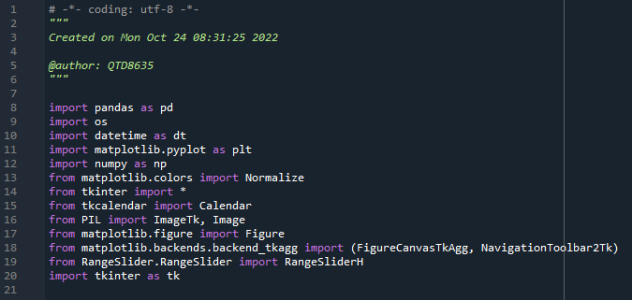
Now depending on if Anaconda was able to be installed or not will play a role in what libraries are needed. Certain libraries are also a part of Python’s standard library and should be preinstalled. At the minimum, I believe tkcalendar and RangeSlider will need to be installed. Luckily, regardless of which libraries are already installed, it is the same process for all libraries.
To install a library, type “pip install ______ --proxy=http://proxy.muc:8080” in the console
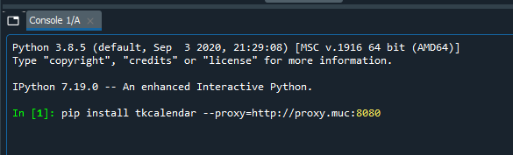
If the installation errors, “--user” being added to the end of the line may help. The installation may also error if the library is already installed. The console will let you know of the issue and recommend what you should do.
Once all the libraries that are directly imported are installed, try running the program. It still might error if an additional library is called by the other libraries that is missing. If this occurs, follow the same procedure for the missing library.

Folder List.xlsx
The spreadsheet “Folder List.xlsx” determines which robots are available for each PC and contains the total list of all pcs. The spreadsheet has 4 columns: “PC Name”, “Robots”, “Works”, and “Config”. Only “PC Name” and “Robots” are used by the script. The other columns are to help the user to hard code specific PCs if needed. If the spreadsheet needs to be changed, only the first 2 columns are required, and the “Robots” column needs to follow the comma delimited format.
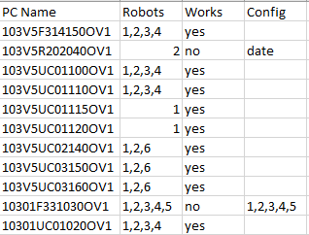

Running the script
Once the script will run without erroring, a window should appear like this picture:
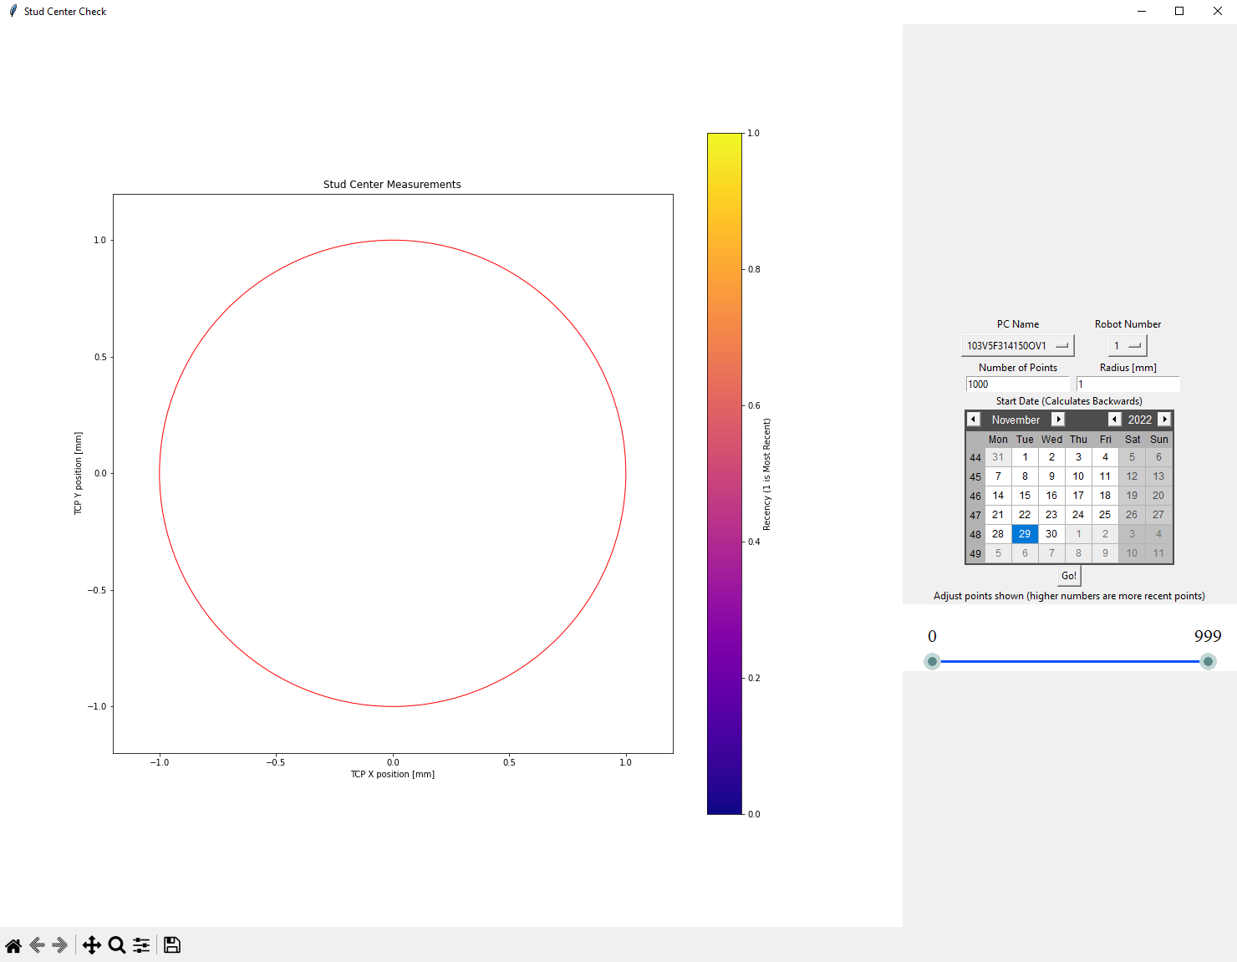
As the script is a GUI, it is reactive to the user. The user can change the PC name, robot number, number of points, radius, and start date prior to displaying points. Once the user is ready to display points, pressing the “Go!” button will remake the figure with points.
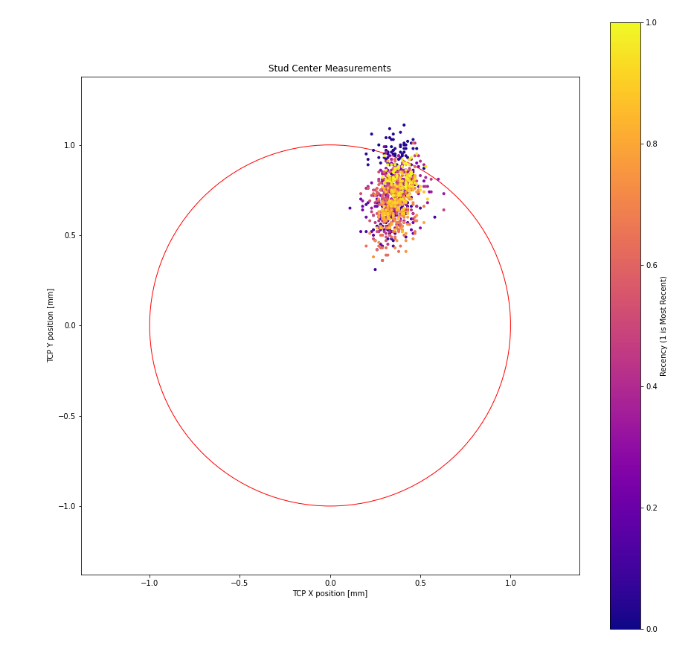
The slider can adjust which of these points are specifically shown and hovering over a point will display information about the point.
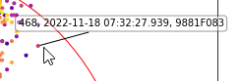
The toolbar on the bottom of the window can be used to adjust the figure view and can save a particular figure.
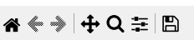

How the script works
As the script is a GUI, after an initial setup, its actions are completely determined by a user’s actions.
The script itself is well commented on explaining the logic within it. Below is a flowchart which explains what the script is doing when the user does different things.

Events:
- Mouse movement within figure
  - Checks mouse position
  - If the cursor is over a point – shows index, date, and EP-NR of point
  - If cursor leaves a point – turns the annotation off
- PC changed
  - Checks which robots are available for new pc
  - Changes the values in the robot drop down
- Slider changed
  - Hides any points whose index is not in the range of the slider
  - Shows any points previously hidden if they become in range of slider
- Go button pressed
  - Runs the data collection and/or plotting procedure based on the user inputs
  - Optimized to only collect data if needed, otherwise, it will update the figure
User inputs:
- PC Dropdown
  - Dropdown of all the stud PCs pulled from “Folder List.xlsx”
- Robot Dropdown
  - Dropdown of the robots at the PC
  - Values shown determined by specific PC selected
- Number of Points Entry
  - Allows the user to specify how many points they want displayed
- Radius Entry
  - Allows the user to specify the circle radius
- Calendar
  - Allows the user to pick a day to start collecting points from
  - Points collect backwards from this day
- Slider
  - Allows for points to be shown/ hidden at will once they have been generated
  - Numbers of slider correspond to point index
- Toolbar
  - Adjusts the view of the figure
  - Can pan, zoom, adjust settings, or save figure

